4 Major Problems in the 2nd Industrial Rev:
Political Corruption
-“You can lead a man to congress, but you can’t make him think.” Milton Berle
Learning Target 2.2 – Describe significant problems created by America’s industrial and urban transformation.
- Describe a time you were ripped off by someone:____________________________________________
________________________________________________________________________________________________________________________________________________________________________
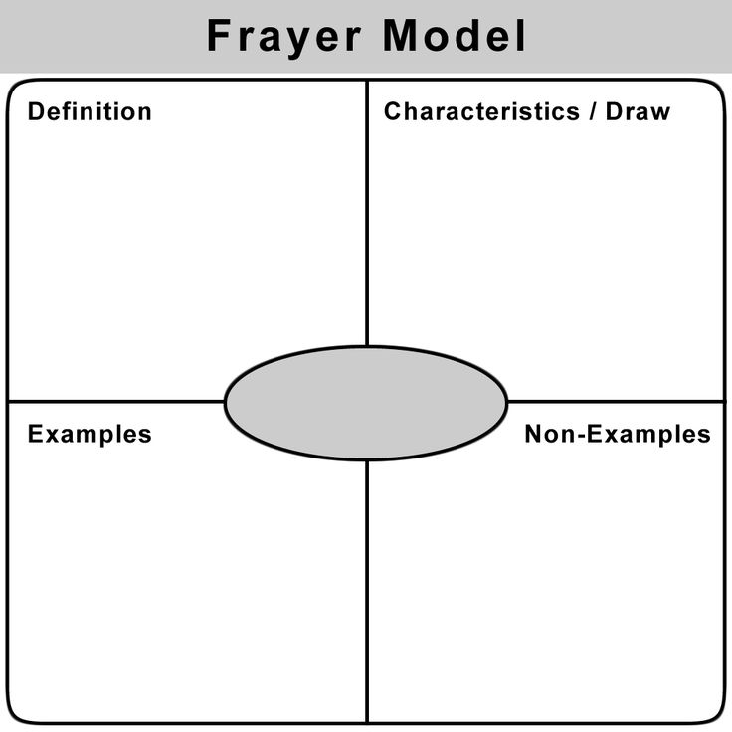
4 Major Problems:
Political Corruption
Corruption at the Local Level
- Political machines were organizations that tried to influence city and county politics. They were okay with breaking the law in order to get people elected to public office who would suppose them. What are some of the ways political machines would gain control of a local government?
  - _____________________________________________________________________________
  - ___________________________________________________________________ __________
  - ______________________________________________________________________________
Tammany Hall, a political machine in NYC was one of the most well-known machines and held tremendous power. Leaders of political machines were known as bosses and none were more powerful than William Marcy Tweed. What were some of the misdeeds of Boss Tweed and how did his luck finally run out?

  - Misdeeds:___________________________________________________________________
  - End of the Road:_______________________________________________________________

_____________________________________________________________________________

______________________________________________________________________________

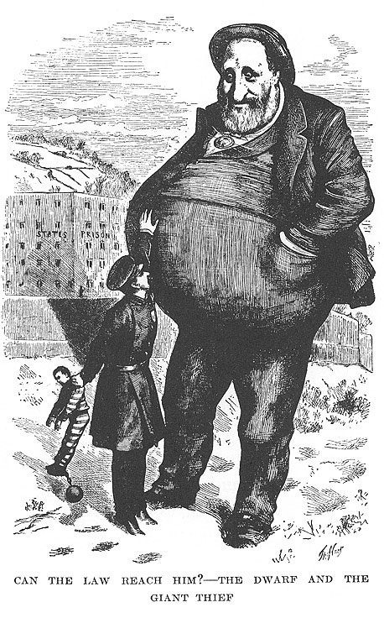
What was the cartoonist to the left trying to show?
_________________________________
_____________________________
_____________________________
_____________________________
_____________________________
_____________________________
_____________________________
_____________________________
4 Major Problems:
Political Corruption
Corruption at the Federal (National) Level
- During the presidency of Republican Ulysses S. Grant (1868-1876) many people began to associate the federal government with corruption as well. Some government officials were thrown out of office and into jail for being a part of the “Whiskey Ring”. Officials took bribes from whiskey distillers (people who make alcohol) to avoid paying taxes. But this was a minor compared to the Credit Mobilier Scandal.

- The Credit Mobilier Scandal happened in 1864 when members of the Union Pacific Railroad formed a construction company called Credit Mobilier. They then hired their newly made company at inflated prices to build their new railroad. This may not seem that bad, except that they were receiving subsidies (money) from the federal government to help build the railroads!

How did Credit Mobilier and Union Pacific get away with this? They sold shares of company stock at low rates to members of congress to keep the good times rolling. Finally in 1872 The Sun broke the story and it resulted in the discovery that over 30 members of congress and received payments from Credit Mobilier. One person connected to it (although he denied charges) was future president James Garfield. Briefly rewrite the scandal in your own words on the lines below:
__________________________________________________________________________________________
___________________________________________________________________ ______________________
__________________________________________________________________________________________
__________________________________________________________________________________________

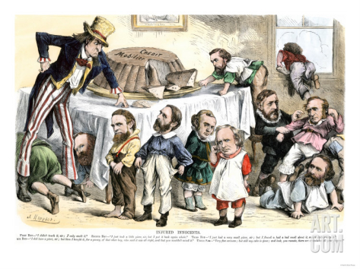
What was the cartoonist to the left trying to show?
_________________________________
_____________________________
_____________________________
_____________________________
_____________________________
_____________________________
_____________________________
_____________________________

