PROGRESSIVISM AND GOVERNMENT REFORMS:
Responses to the Problems of the 2IR
-“A great democracy has got to be progressive or it will soon cease to be great or a democracy.” Theodore Roosevelt
Learning Target 2.3-2.4 –
2.3 - Explain the major changes and limitations of Progressive reforms.
2.4 – Describe the key Progressive response for change.

- Define “Progress” in your own words:____________________________________________________
__________________________________________________________________________________
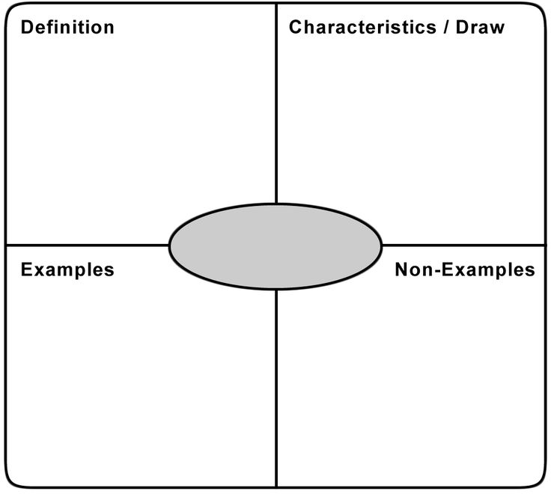
PROGRESSIVISM

PROGRESSIVE REFORMS:
REFORMS & RESPONSES TO 2IR Problems
Child Labor
- With the growth of technology and influx (look it up) of new immigrants, child labor in dangerous conditions had skyrocketed. By 1900 more than 1.75 million children under the age of 15 worked in mines, mills, or factories alone. By the early 1900’s people finally decided it was time to take a stand.

- People like Florence Kelley and Jane Adams and organizations like The National Consumer’s League fought against child labor. On pages 595 and 616 find and describe how these people impacted the following steps to combat child labor:
  - Florence Kelley and the National Consumer League- ____________________________________
______________________________________________________________________________
  - National Child Labor Committee-___________________________________________________
______________________________________________________________________________
  - Jane Adams & Hull House-________________________________________________________
______________________________________________________________________________
For all of these people’s efforts, it was not until 1938 when the Fair Labor Standards Act was passed that most child labor was finally made illegal in the U.S.
Workplace Conditions
- Events like the Triangle Shirtwaist Fire, when 146 workers were killed in a factory as a result of the doors being locked, brought about loud calls for change in the American workplace. Labor unions pushed hard for better pay and safer workplaces. List changed each union pushed for below:

  - Knights of Labor:________________________________________________________________

  - American Federation of Labor:_____________________________________________________

  - Industrial Workers of the World:____________________________________________________

______________________________________________________________________________
While there were improvements in wages, working conditions, and length of workdays, national laws regulating treatment of labor was still a long way off.

Monopolies
- Corporations like Rockefeller’s Standard Oil were gaining far too much control over American life and the U.S. government finally took effective steps towards stopping their influence in the early 1900s. Below, describe the following terms (with dates) and their influence in limiting big business power

  - Interstate Commerce Act/Commission-______________________________________________

Effective?-_____________________________________________________________________

  - Sherman Antitrust Act___________________________________________________________

Effective? - ____________________________________________________________________

  - Clayton Antitrust Act:____________________________________________________________

  - Federal Trade Commission:________________________________________________________
Finally with the Clayton Antitrust Act and the Federal Trade Commission the US had laws that would stop big businesses from taking advantage of their power.

Political Corruption
- Due to the corruption of the Gilded Age, there were many reforms that came about during the Progressive Era. One group of people that brought about these reforms were the muckrakers. Muckrakers were journalists who exposed the bad stuff in government and big business. They pressured the government into passing new laws to help fix the system. A few examples of their influence:
- 17th Amendment-_______________________________________________________________
___________________________________________________________________
- Recalls-________________________________________________________________________
___________________________________________________________________
- Pendleton Civil Service Act-________________________________________________________
___________________________________________________________________
- Ida Tarbell-____________________________________________________________________
___________________________________________________________________

