New York Tenements 19th Century
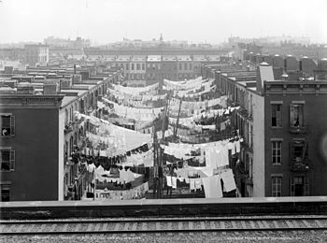
As the United States industrialized during the 19th century, immigrants and workers from the countryside were housed in former middle-class houses and other buildings, such as warehouses, which were bought up and divided into small dwellings,[6][7] and also, beginning as early as the 1830s on the Lower East Side[4] or possibly the 1820s on Mott Street,[8] in jerry-built 3- and 4-floor "railroad flats" (so called because the rooms are linked together like a train)[9] with windowless internal rooms. The adapted buildings were also known as "rookeries," and were a particular concern as they were prone to collapse and fire. Mulberry Bend and Five Points were the sites of notorious rookeries that the city worked for decades to clear.[8] In both rookeries and purpose-built tenements, communal water taps and water closets (either privies or "school sinks," which opened into a vault that often became clogged) were squeezed into what open space there was between buildings.[9] In parts of the Lower East Side, buildings were older and had courtyards, generally occupied by machine shops, stables, and other businesses.
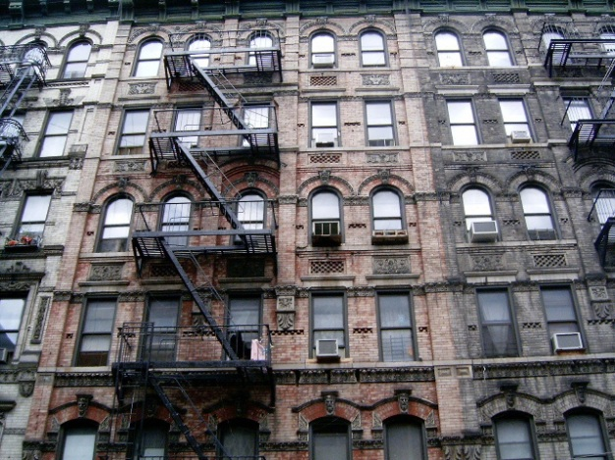
Such tenements (or "walk-ups") were particularly prevalent in New York, where in 1865 a report stated that 500,000 people lived in unhealthy tenements, whereas in Boston in 1845 less than a quarter of workers were housed in tenements.[4] One reason New York had so many tenements was the large numbers of immigrants; another was that the grid pattern on which streets were laid out and the economic practice of building on individual 25- by 100-foot lots combined to produce extremely high land coverage, including back building.[11] Prior to the 1867 law, tenements often covered more than 90 percent of the lot, were five or six stories high, and had 18 rooms per floor of which only two received direct sunlight. Yards were a few feet wide and filled with privies where they had not been entirely eliminated. Interior rooms were unventilated.[9]
Early in the 19th century, many of the poor were housed in cellars, which became even less sanitary after the Croton Aqueduct brought running water to wealthier New Yorkers: the reduction in well use caused the water table to rise, and the cellar dwellings flooded. Early housing reformers urged the construction of tenements to replace cellars, and beginning in 1859 the number of people living in cellars began to decline.[12]

