The Second Industrial Revolution:
How the U.S. Became an Industrial Power

-“Actual revolution which affects wholesale societal change is only seen via technological advancement i.e. industrial.” L________________

Learning Target 1.1 – Define “industry”; Identify the resources, inventions, and people that helped the U.S. become an industrial power.

- Define “Industry” in your own words:____________________________________________________
__________________________________________________________________________________
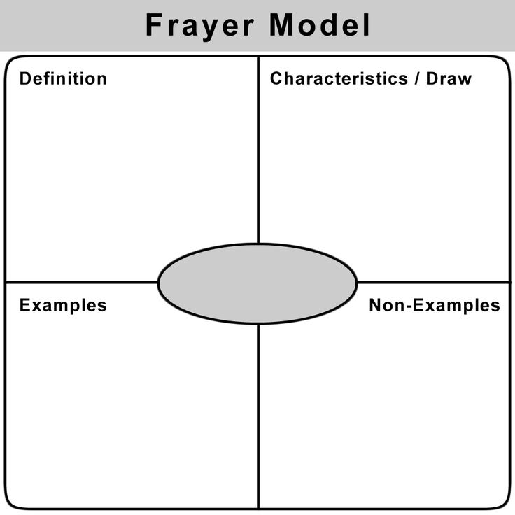
The Resources and Inventions:
Steel, Railroads, & Power
“STEEL IS KING!”
- The driving force behind the growth of industry in the United States was the advances in technology that made travel easier and faster. The railroads are the best early example of this and they benefited greatly from a drop in construction costs as a result of the “Bessemer Process”.
  - Bessemer Process-____________________________________________________
___________________________________________________________________
At first mocked, this process allowed U.S. steel production to skyrocket. While it contributed to taller buildings, bridges, and household items its most significant impact was seen in the use steel rails for railroads. Railroad companies made up the largest source of orders for the steel industry early on and the two grew into economic behemoths. Find 2 significant statistics for the steel industry on pg. 579:

  - ___________________________________________________________________
  - ___________________________________________________________________
By 1890 the U.S. steel industry was producing 1/3 of the world’s supply of steel and by 1900 America produced as much as Britain and Germany combined. This was the start of an era that changed America’s standing in the world economically and politically.

FEEDING THE IRON (now steel) HORSE: THE EXPANSION OF RAILROADS
- With the cheaper price of steel, the railroads started to expand at a quick pace, crisscrossing the once vacant prairies and displacing anyone in their way. Use the handout from The American Pageant about the growth of the railroad industry and its impact to create a web diagram of main ideas about the “Railroad Industry”.

NEW SOURCES OF POWER
- Invention was happening all over America as the economy improved. Alexander Graham Bell invented in the telephone, mass production factories, and typewriter had major impacts on daily life. Two developments had a larger sphere of influence than any of the others: oil as a power source and electric light. These inventions changed life in ways as dramatic as allowing people to travel in planes over long distances and as simply as dropping the average amount of sleep for Americans from nine hours of sleep a night to seven. Using your textbook pg. 580, describe how oil changed life in America and a timeline of Thomas Edison’s experiences with the light bulb.
Describe the Influence of Oil as a Power Source: ________________________________________________
__________________________________________________________________________________________
__________________________________________________________________________________________
__________________________________________________________________________________________
__________________________________________________________________________________________

Timeline of Thomas Edison & the Light Bulb:

___________________________________________________________________

Quiz yourself: Write a definition of industry; identify the major resource that started to influence the growth of railroads and the invention that led to it.
Industry:______________________________________________________________________
Railroads:_____________________________________________________________________
_____________________________________________________________________________
_____________________________________________________________________________
_____________________________________________________________________________

THE LEADERS OF THE INDUSTRIAL REVOLUTION
- Identify the main idea for each paragraph by finding the topic sentences of each identified paragraph. The evidence can also be summarized and come from multiple sentences.

JOHN D. ROCKEFELLER
- Paragraph 2 Main Idea: ________________________________________________________________
Evidence:________________________________________________________________________________________________________________________________________________________________
- Paragraph 3 Main Idea: ________________________________________________________________
Evidence:________________________________________________________________________________________________________________________________________________________________
- Paragraph 4 Main Idea: ________________________________________________________________
Evidence:________________________________________________________________________________________________________________________________________________________________
- Paragraph 5 Main Idea: ________________________________________________________________
Evidence:________________________________________________________________________________________________________________________________________________________________
- Paragraph 6 Main Idea: ________________________________________________________________
Evidence:________________________________________________________________________________________________________________________________________________________________
- Paragraph 7 Main Idea: ________________________________________________________________
Evidence:________________________________________________________________________________________________________________________________________________________________
- Paragraph 8 Main Idea: ________________________________________________________________
Evidence:________________________________________________________________________________________________________________________________________________________________
THE LEADERS OF THE INDUSTRIAL REVOLUTION
- Identify the main idea for each paragraph by finding the topic sentences of each identified paragraph. The evidence can also be summarized and come from multiple sentences.

ANDREW CARNEGIE
- Paragraph 2 Main Idea: ________________________________________________________________
Evidence:________________________________________________________________________________________________________________________________________________________________
- Paragraph 3 Main Idea: ________________________________________________________________
Evidence:________________________________________________________________________________________________________________________________________________________________
- Paragraph 4 Main Idea: ________________________________________________________________
Evidence:________________________________________________________________________________________________________________________________________________________________
- Paragraph 5 Main Idea: ________________________________________________________________
Evidence:________________________________________________________________________________________________________________________________________________________________
- Paragraph 6 Main Idea: ________________________________________________________________
Evidence:________________________________________________________________________________________________________________________________________________________________
- Paragraph 7 Main Idea: ________________________________________________________________
Evidence:________________________________________________________________________________________________________________________________________________________________
- Paragraph 8 Main Idea: ________________________________________________________________
Evidence:________________________________________________________________________________________________________________________________________________________________

MONOPOLIES, TRUSTS, HORIZONTAL & VERTICAL INTEGRATION:
BUSINESS PRACTICES OF THE ROBBER BARONS/CAPTAINS OF INDUSTRY

